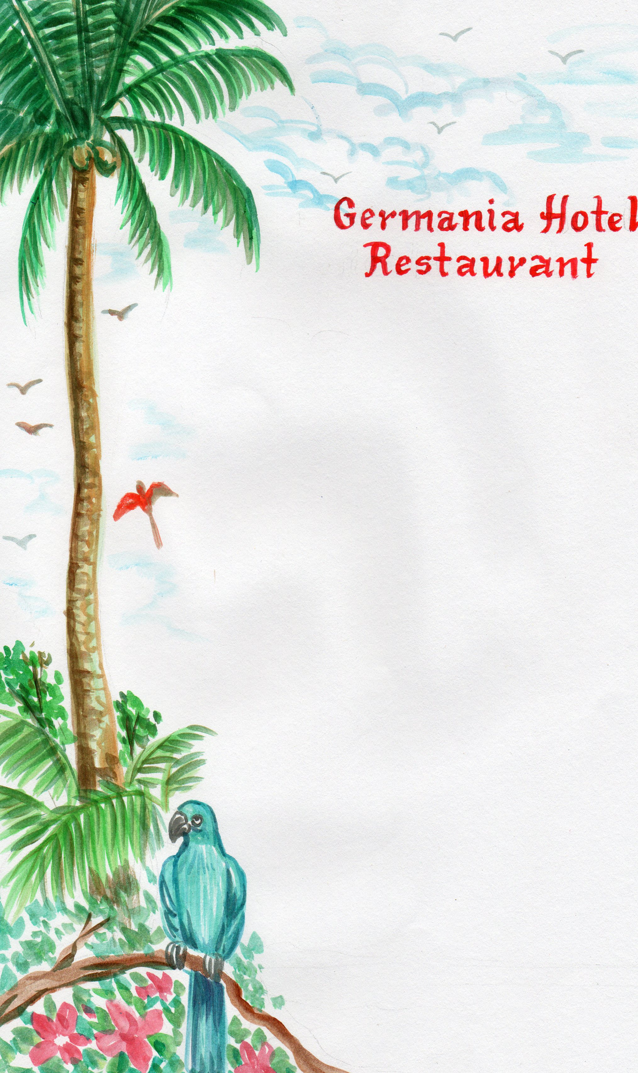**Special Breakfast**

3Eggs any style, 3 slices Bacon

Home fried Potatoes

with Toast, Butter and Marmalade

1 Glass Juice (Mango, Pineapple or Orange)Slices of fresh Fruits

and Tea or Coffee with (Refill once)

₱340 Pesos